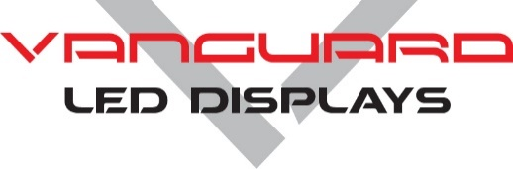**Product** **Specifications**

**AXION Pro SERIES**

**Indoor P1.56 Fine Pixel Pitch LED Display**

**• 16:9 aspect ratio**

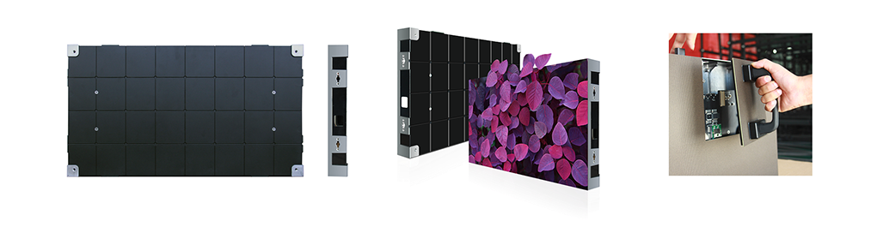

**Overview**

The Axion Series cabinets have a native aspect ratio of 16:9. When 16:9 cabinets are arrayed with equal cabinet height & width (i.e. 10x10 or 8x8), the entire display will retain a 16:9 viewing aspect ratio. Axion is available in pixel pitches of P0.94, P1.25, P1.56, P1.875, P2.5.

Axion is fully front serviceable. There are no external jumpers on the rear, making this cabinet ideal for wall mounting. Axion cabinets are designed for wall mounting and can be recessed into a wall. At only 2.28” deep, the Axion cabinet can be wall mounted to meet ADA requirements. Pre-threaded mounting locations make installation simple. Magnetic LED modules make module replacement quick & easy.

Vanguard LED Displays offer a five (5) year warranty and 5% spare parts.

This product is TAA approved and is suitable for DoD, Federal, State, and Local Agency Simulation Training Simulations as well as Maritime and large aircraft trainers.

**Additional Features**

* IC drivers allow for customizable refresh & scan rates.
* Receiving cards allow for custom gray levels from 14-18 bit.
* Redundant power & data are available.
* No internal ribbon cables. There is a single cable-less PCB connection for data & power.
* 90 Degree angle cabinets are an available option.
* Seam brightness compensation is a standard feature.
* High gray scale & refresh rates.
* Resin encapsulated LED modules available for increased durability.
* Half size cabinets are available.
* Smart module data retention.
* Superb color & brightness uniformity.
* DC-DC Remote Power Supply available.
* Low latency available- Reduction from 4 frames to .5 frames.
* Contrast Ratio: 3000:1

**Axion Technical Specifications**

Specifications

Axion Indoor P1.56

INTERNAL CONNECTIONS

Axion has no external connections

100% internal connections inside cabinet

Data in / out RJ45

AC Power in / out IEC

CABINET

Aspect Ratio 16:9

Cabinet Material Die Cast Aluminum

Cabinet Size 23.62” x 13.28” x 2.28”

Cabinet Resolution 384 x 216

Cabinet Weight 17 lbs.

Service Access Front

IP Rating IP30

ENVIRONMENTAL

Operating Temperature -10°C to +50°C

Storage Temperature -20°C to +60°C

Operating Humidity 20% to 90% RH

AC POWER

Source Voltage 100-240V, 50/60Hz

Max Power Consumption 165W

Avg. Power Consumption 85W

INTERNAL OPERATION

Driving Method 1/27th Scanning

Gray Scale 14-18 bit

IC Driver MBI5153

Refresh Rate >3840Hz

Frame Frequency 60Hz

LED

LED Type SMD1010

LED Configuration 3 in one

Pixel Density 390,625/m²

Module Size 11.81” x 6.64”

Module Resolution 192 x 108

Modules Per Cabinet 4

Lifetime to Half Brightness (L50) 100,000

Contrast Ratio 3,000:1

Brightness 600-800Nits

Viewing Angle 160° x 160°

Minimum Viewing Distance 5.28 ft.